HACKUP TECHNOLOGY PVT.LTD

INTERNSHIP : AI – POWERED SOC & DIGITAL FORENSICS
WEEK – 2 : PROJECT 3 REPORT

BY :
P. AKSHAYA (24202)
B.SC.CS (SSS)

AI – POWERED SOC & DIGITAL FORENSICS

WEEK – 2 : (SIEM AND THREAT DETECTION)
PROJECT – 3 : ( INGEST LOGS INTO WAZUH AND CREATE ALERTS FOR FAILED LOGIN ATTEMPTS )

INTRODUCTION
The project mainly focused on collecting and analyzing system logs using Wazuh. Authentication logs and SSH logs were monitored to detect suspicious activities such as failed login attempts and unauthorized access attempts.By using Wazuh, students learned how security alerts are generated automatically whenever suspicious activity occur in a system

OBJECTIVES
The main objectives of this project are:
- To understand the architecture and working process of the Wazuh security monitoring platform.
- To collect and ingest system logs into the Wazuh Manager.
- To monitor authentication logs and SSH activity in Linux systems.
- To identify and detect failed login attempts automatically.
- To generate and analyze security alerts created by Wazuh.

TOOLS USED
Wazuh - | Used for security monitoring, log analysis, and alert generation
Kali Linux - | Used as the environment for installing and running Wazuh
Syslog / SSH Logs - | Used as the source of authentication and login event logs
Linux Terminal - | Used for monitoring logs and performing analysis
Wazuh Dashboard - | Used for visualizing alerts and analyzing security events

PROJECT ARCHITECTURE
1. Agent / System Logs
2. Wazuh Manager
3. Alert Engine
4. Wazuh Dashboard
5. Methodology

STEP 1: INSTALLING AND CONFIGURING WAZUH
Installing a Wazuh Manager on Kali Linux and configure the required monitoring settings. in this step, Wazuh was ready to receive and analyze system logs properly.
Steps:
- Starting Wazuh services
- Enabling log monitoring
- Configuring authentication log collection
- Verifying manager connectivity
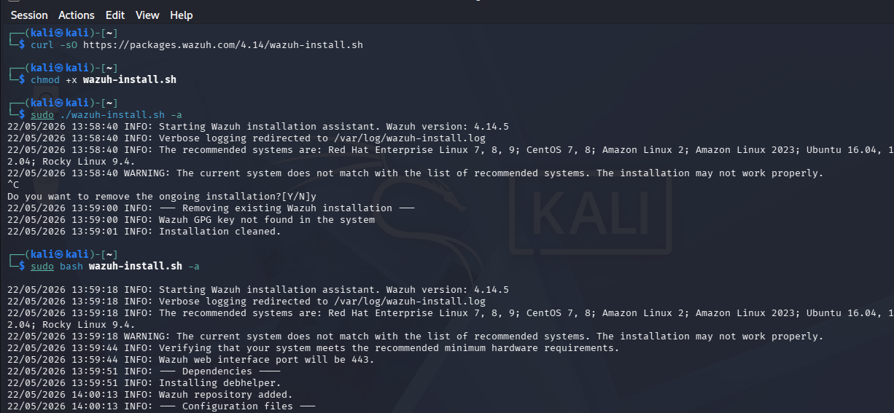

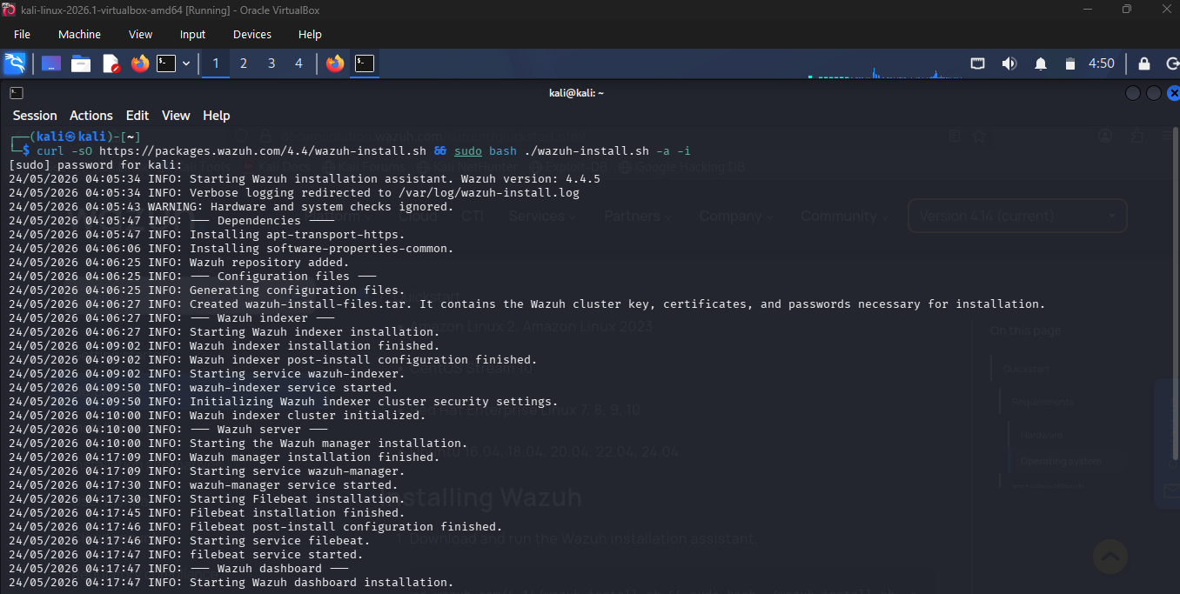

After a installation to check a ip address using ifconfig and open a browser to type a
[ https://10.0.2.15 ] then wazuh will be opened .

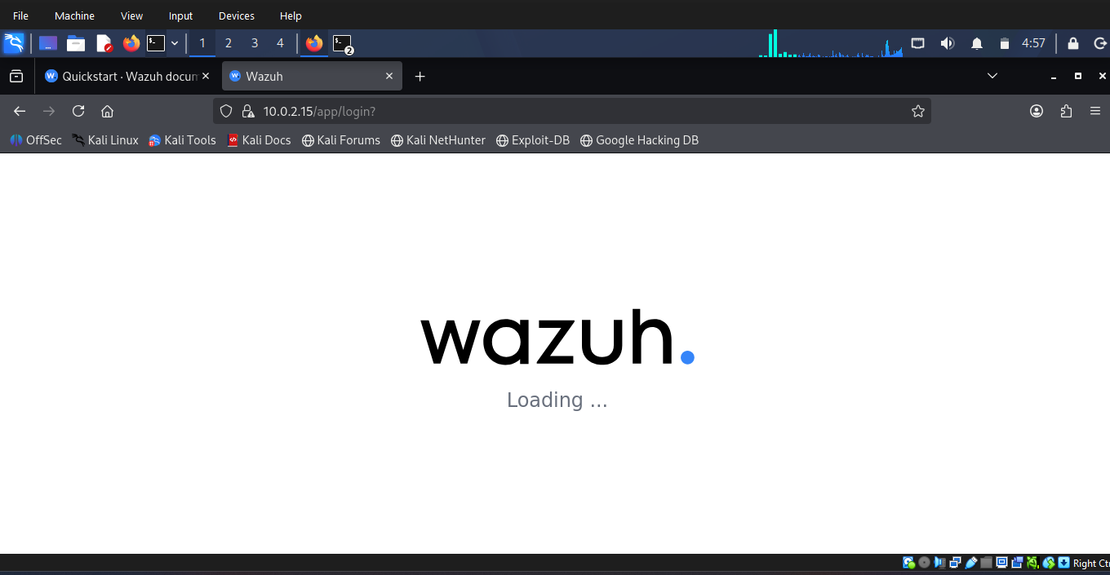

STEP 2: LOG INGESTION
In this step , authentication logs from Linux systems were collected and sent to Wazuh for analysis.
The main log file used was:
/var/log/auth.log
These logs contained important security-related events such as SSH login attempts , Sudo activities , Failed password attempts . Wazuh continuously monitored in these logs.

STEP 3: GENERATING FAILED LOGIN ATTEMPTS
To test the monitoring system, failed login attempts using incorrect usernames and passwords.
Example Commands
ssh fakeuser@localhost (or) ssh wronguser@localhost
These commands produced failed authentication events inside the log files.
Wazuh detected these suspicious activities automatically and generated security alerts.
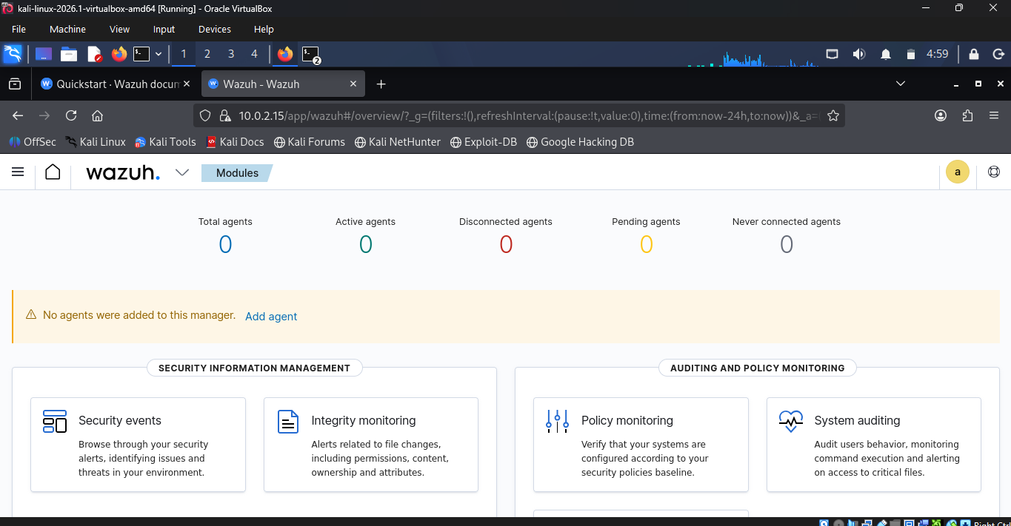

Start a wazuh using a terminal and check the status of a wazuh tool

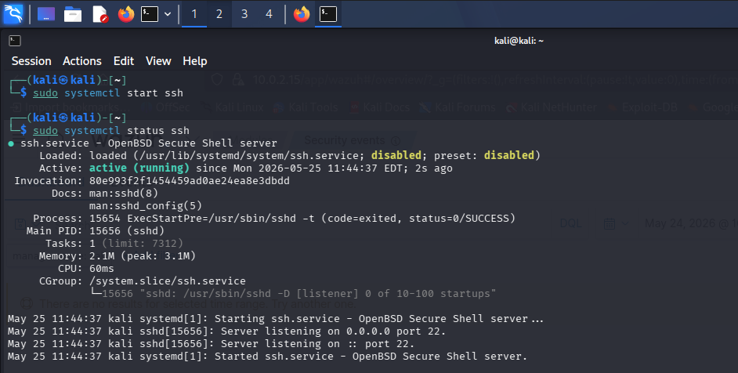

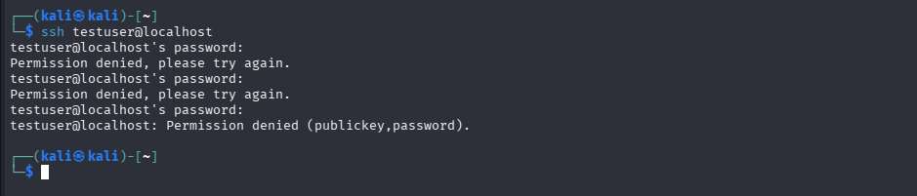

STEP 4 :
In this step open a wazuh choose a dashboard -> discover -> search a filter and put the command “manager .name: kali AND (sshd) ” now we will see the hits .
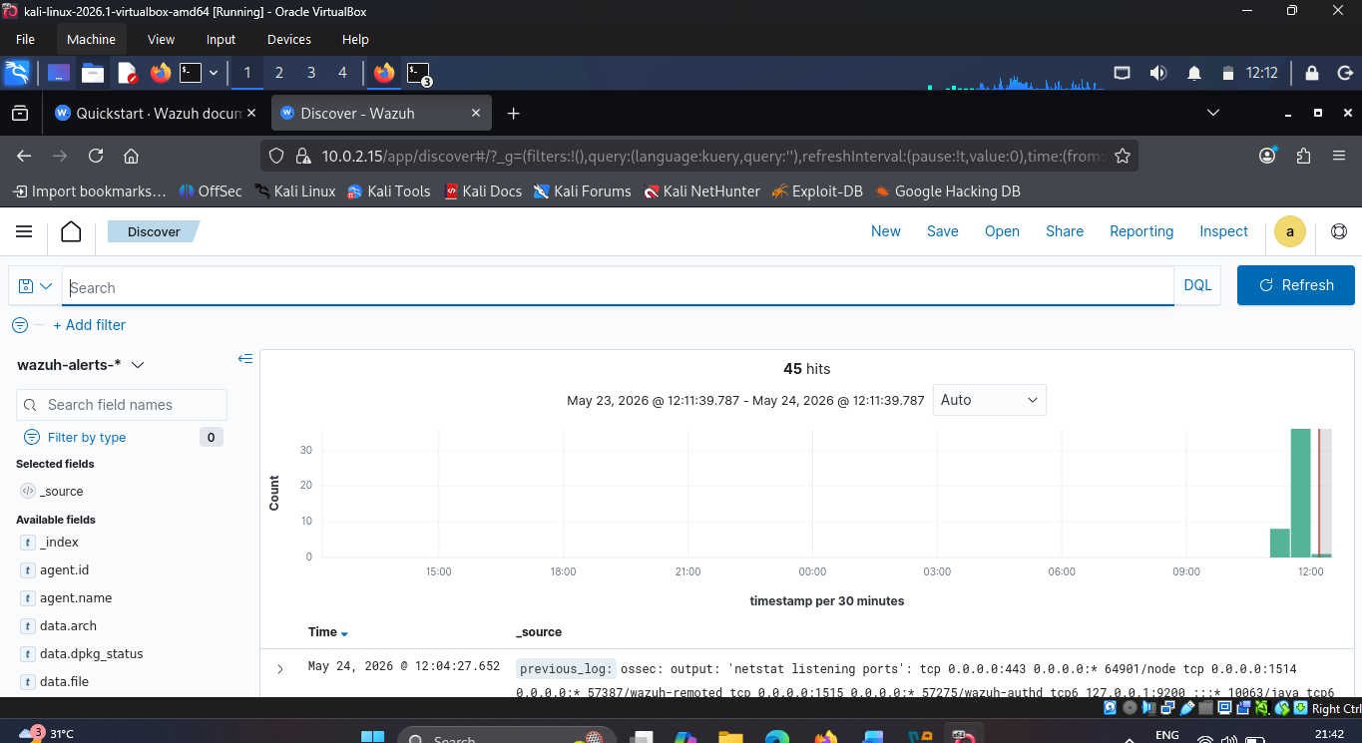

Dashboard -> security events -> now will see a authentication success attempts and authentication failure attempts .
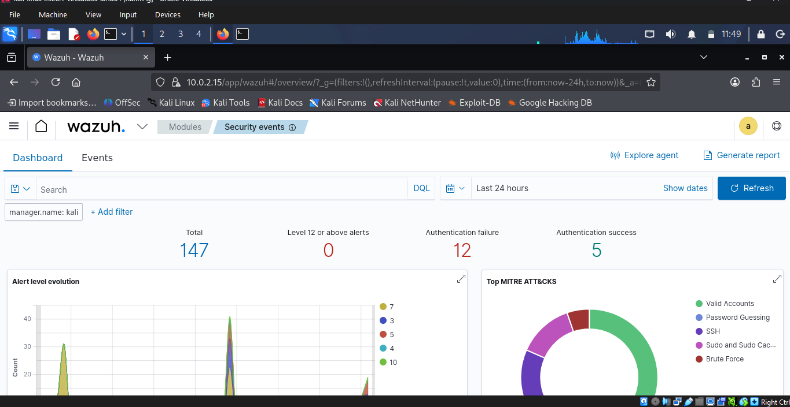

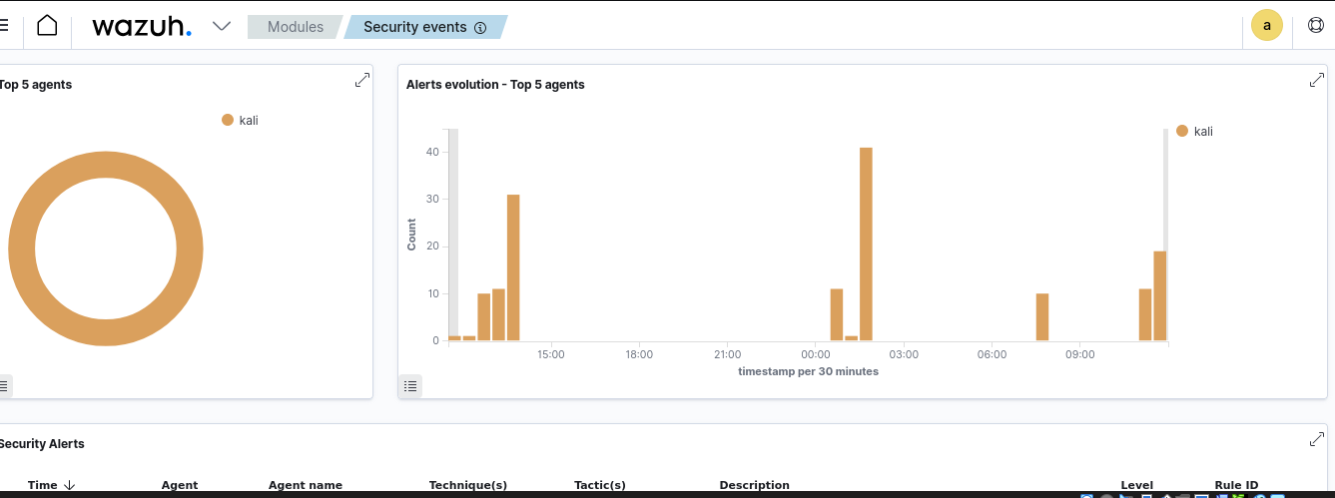

STEP 5 : LOG ANALYSIS AND ALERT DETECTION
After log collection was configured successfully, Wazuh analyzed the logs and detected suspicious authentication activities.
The platform generated alerts whenever abnormal login behavior was identified.
Important Detected Alerts
Rule ID | Description | Level | Count
5710 | SSH login attempt using non-existent user | 5 | 8
2502 | User entered wrong password multiple times | 10 | 2
5503 | PAM user login failed | 5 | 2
Analysis
The generated alerts clearly showed that Wazuh successfully identified:
- Unauthorized access attempts
- Invalid SSH users
- Failed authentication activities
This proves that the monitoring system was functioning correctly.

ADVANTAGES OF WAZUH :
- Real-time threat detection
- Open-source SIEM platform
- Centralized log monitoring
- Rule-based alert generation
- Easy-to-use dashboard visualization
- Supports compliance and security monitoring
These features make Wazuh suitable for security operations and incident monitoring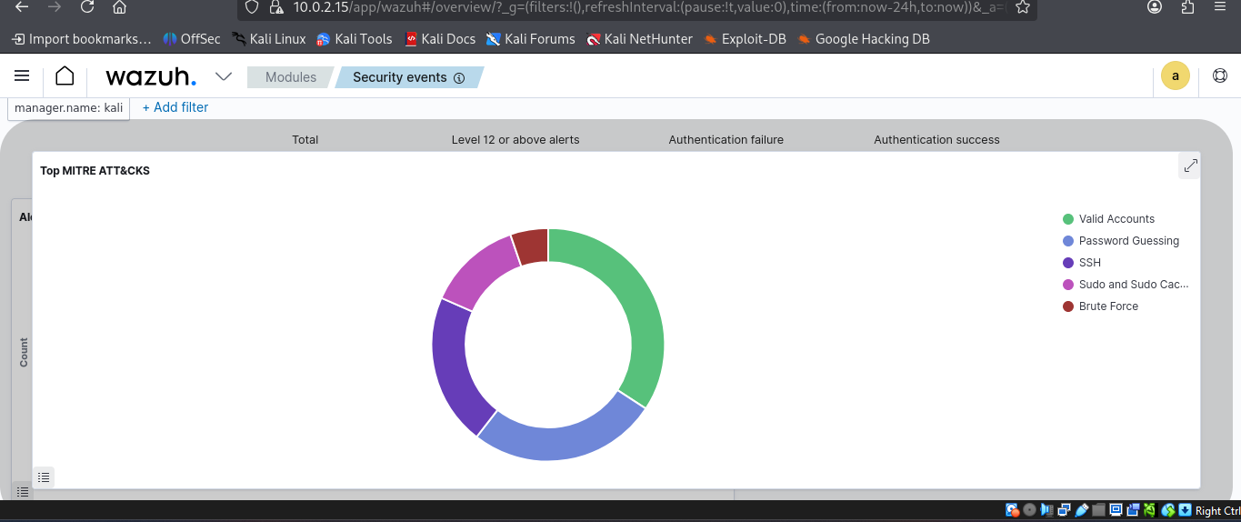

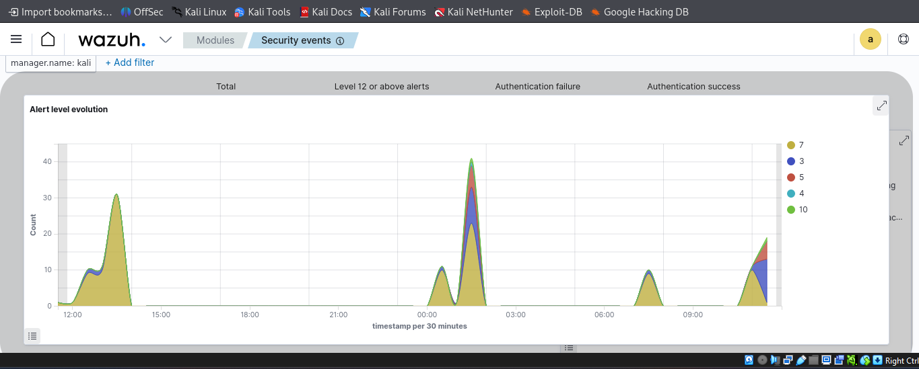

This report will generated by a wazuh

Conclusion
This project demonstrated how the Wazuh platform can be used as an effective SIEM solution for cybersecurity monitoring and failed login detection.
- Collected and ingested logs
- Generated suspicious login attempts
- Monitored authentication activities
- Detected security alerts
- Analyzed events using the Wazuh Dashboard
Overall, Wazuh provides a reliable and efficient platform for monitoring cybersecurity events in Linux environments.

